**Task 8 -ChatGPT**

Applying colors and backgrounds in CSS is essential for creating visually appealing web pages. Here’s a guide on how to use different color formats (hex, RGB, HSL) and various background properties (solid color, gradient, image) with an example.

**Applying Colors in CSS**

1. **Hexadecimal (Hex)**: A six-digit code representing colors using the RGB color model. For example, #FF5733 represents a shade of red.
2. **RGB**: Uses the rgb() function to define colors based on their red, green, and blue components. For example, rgb(255, 87, 51) represents the same shade of red.
3. **HSL**: Uses the hsl() function to define colors based on hue, saturation, and lightness. For example, hsl(10, 100%, 60%) represents a shade of red.

**Background Properties in CSS**

1. **Solid Color**: A single color applied to an element.
2. **Gradient**: A smooth transition between two or more colors. CSS supports linear and radial gradients.
3. **Image**: A background image applied to an element.

**Example HTML and CSS Code**

Here’s an example that demonstrates various ways to set colors and backgrounds:

**HTML Structure**

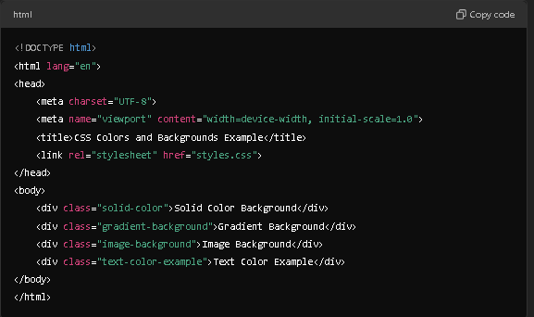

**CSS Styles (styles.css)**

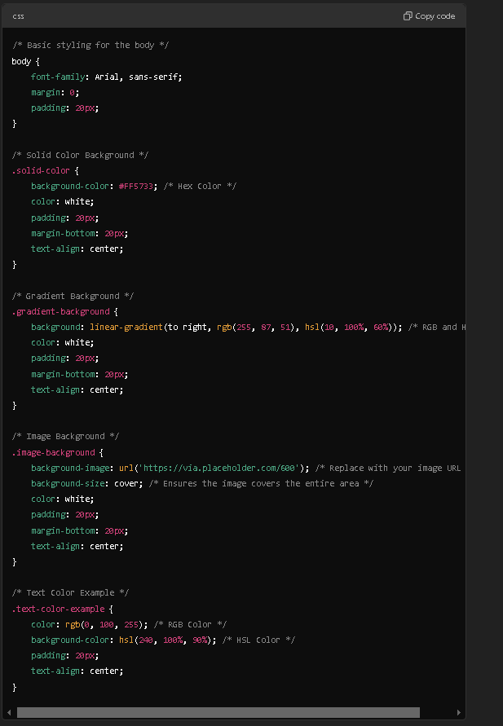

**Result   
**

**Explanation of the Example**

1. **Solid Color Background**:
   * The **.solid-color** class applies a solid background color using a hex value **(#FF5733**). The text color is set to white for contrast.
2. **Gradient Background**:
   * The .**gradient-background** class demonstrates a linear gradient that transitions from an RGB color (**rgb(255, 87, 51)**) to an HSL color (**hsl(10, 100%, 60%)**). This creates a smooth color transition.
3. **Image Background**:
   * The **.image-background** class uses a background image from a placeholder URL. **The background-size: cover**; property ensures the image covers the entire div area, maintaining its aspect ratio.
4. **Text Color Example**:
   * The .**text-color-example** class showcases how to set text color using RGB (**rgb(0, 100, 255)**) and a light background color using HSL **(hsl(240, 100%, 90%)).**

**Conclusion**

This example illustrates various methods to apply colors and backgrounds in CSS, showcasing different color formats and background styles. You can modify the hex, RGB, and HSL values or the background image URL to experiment with different looks! If you need any more specific examples or explanations, just let me know!